Email
Email Support Guide
Version 1.0

Table of Contents
Email SetUp 2
1 Connecting your mailbox through POP 2
2 Connecting your mailbox through IMAP 2
3 iPhone & iPad Email Set Up 3
4 Setting up automatic replies in Webmail 7
5 Setting up email in Outlook 2007 8
6 Setting Up Email in Outlook 2010 11
7 Setting up email in Outlook 2016/2019/365
8 Setting up email in Outlook 2011 for Mac 16
9 Setting up email in Outlook 2016 for Mac 18
10 Setting up email in Windows Live Mail 19
11 How to setup email in Windows 10 Mail
12 How do I Set up Filters in Webmail 21
13 Setting up your email account on Apple Mail 23

Email Trouble Shooting 25
14 I received a notification that my mailbox is nearly full? 25
15 How to access emails whilst abroad 25
16 How to increase your mailbox size 25
17 I can receive emails but can’t send emails? 26
18 Why have I suddenly started to receive lots of "message delivery failed" messages? 27
19 How can I reduce the amount of spam emails I receive? 27

Email SetUp
- Connecting your mailbox through POP
If you have an email client which requires a manual setup and need the correct details to fill in, you will be able to use the following information to get up and running through the protocol POP.
Incoming Mail Server: pop.clara.net
Incoming Port: 110, SSL Off.
995, SSL On.
Outgoing Mail Server: relay.clara.net
Outgoing Port: 25, SSL Off.
2525, SSL Off.
587, SSL Off.
465, SSL On.

- Connecting your mailbox through IMAP
If you have an email client which requires a manual setup and need the correct details to fill in, you will be able to use the following information to get up and running through the protocol POP.
Incoming Mail Server: imap.clara.net
Incoming Port: 143, SSL Off.
993, SSL On.
Outgoing Mail Server: relay.clara.net
Outgoing Port: 25, SSL Off.
2525, SSL Off.
587, SSL Off.
465, SSL On.

- iPhone & iPad email set up
- Go to Settings

- Go to Password & Accounts and select Add Account
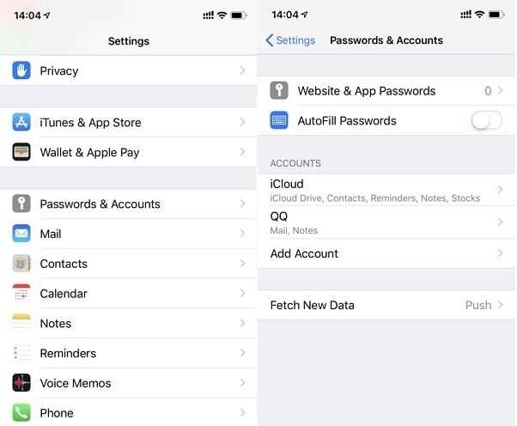

- On the list of account types, select Other.
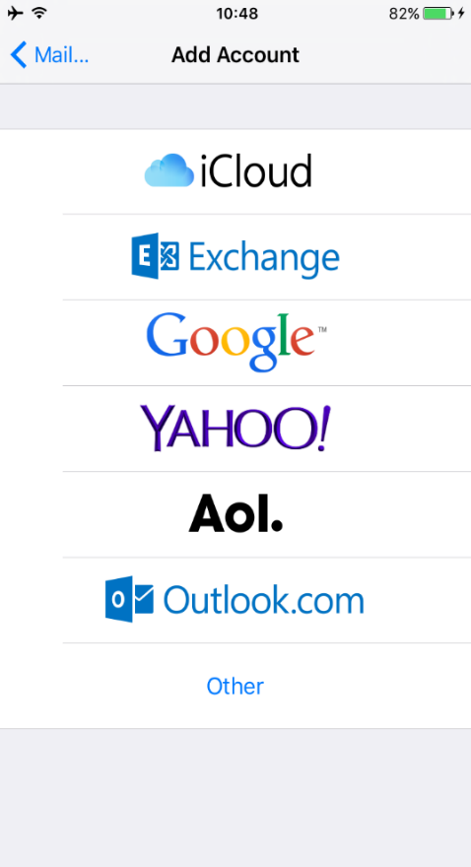
- Select Add Mail Account.
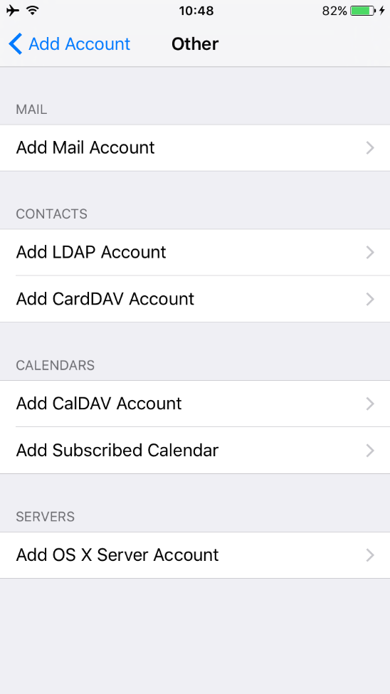
- You will then need to enter your Name, Email and Password then press Next.
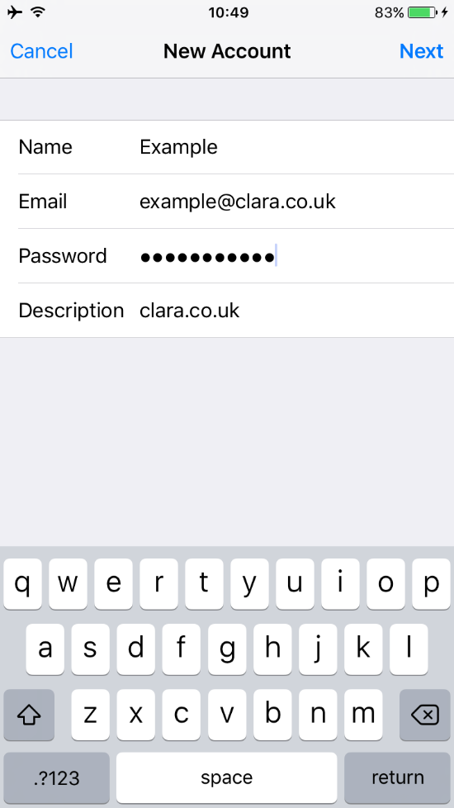

- You will then need to select POP at the top of the page so it’s highlighted in blue.
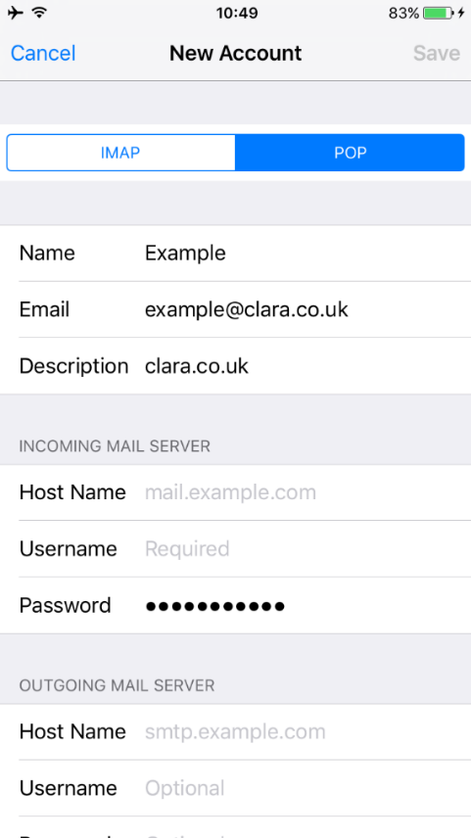
- You will then need to enter the server information as shown below, replacing the username with your full email address. Once done, press Save in the top right, this will verify the details entered. If it’s all correct, it will appear with several blue ticks.
If incorrect it will display a message saying username or password are incorrect, you will then need to retype the email address and password.

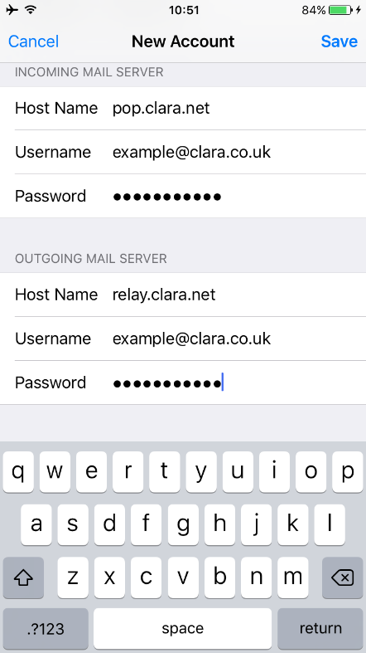

- Setting up automatic replies in webmail
Firstly, you will need sign in to webmail on the following link: https://webmail.clara.net/src/login.php
You will need to sign in with your full email address as the Username and the Password is your email password. Once typed in the information press Login.
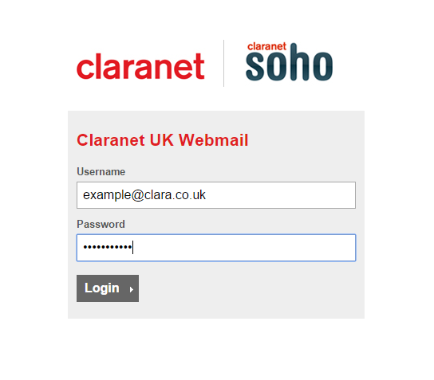
Once you have logged in select Settings in the top right
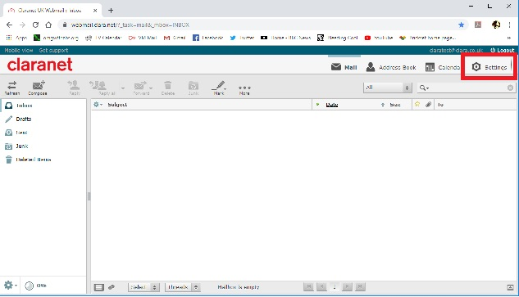

Select Autoresponder on the left
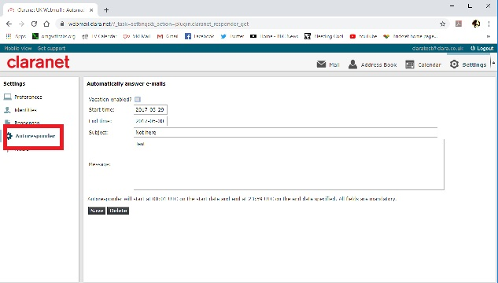

Tick the box for Vacation enabled?
Select the Start time
Select the End time
Give it a Subject
Enter Message you want the recipient to see, click Save

Please take note senders will only receive one response during the period of the automatic reply

- Setting up email in Outlook 2007
Once in Outlook 2007 you will need to click the Tools option from the menu bar. Then from the list of options you will need to select Account Settings.
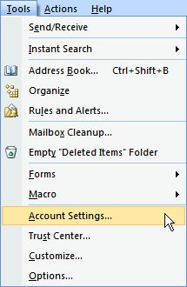
Then you will be presented with the screen below and you will need to click the option for New under the Email tab.
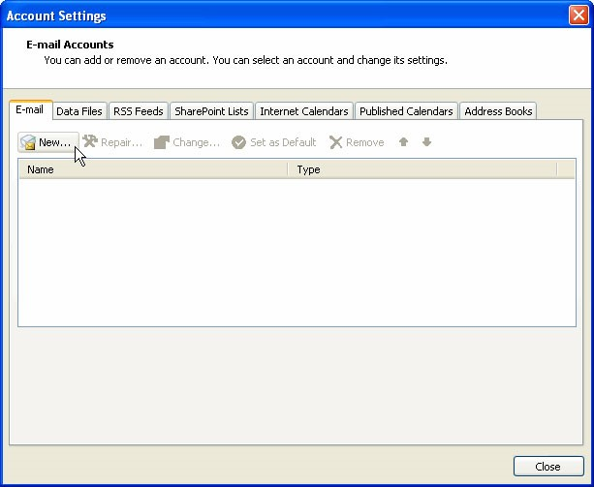
On the next screen you will need to select the option to Manually configure the server settings and then click Next.
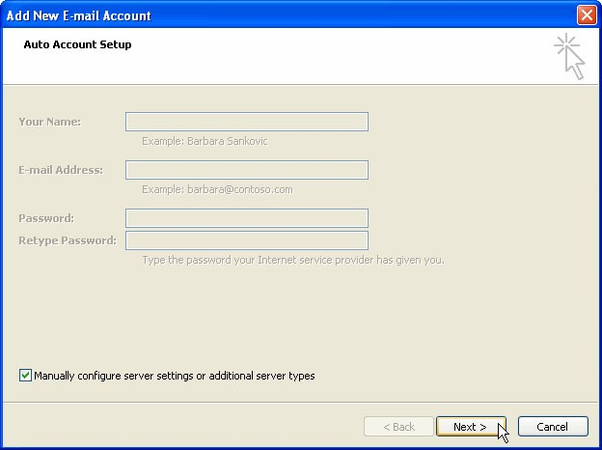
Select the option for Internet Email and click Next.

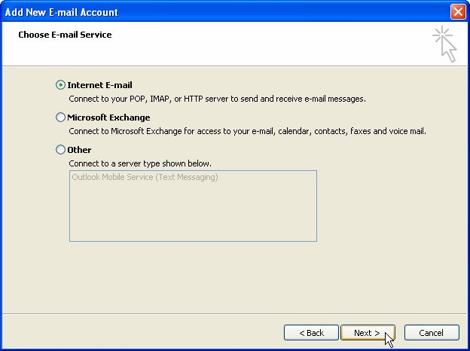

Enter the server settings, pop.clara.net for incoming and relay.clara.net for outgoing. Depending on how the account is to be setup, enter your Username and Password and click More settings.
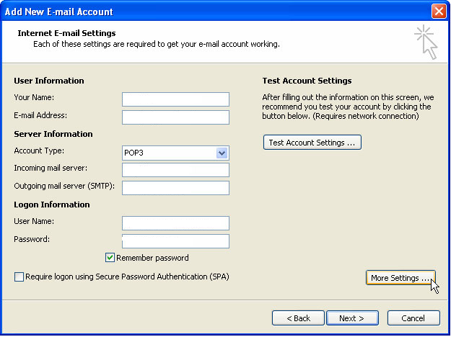
On the following screen you will need to select the Outgoing Server tab and ensure there is a tick in the My outgoing server (SMTP) server requires authentication box.
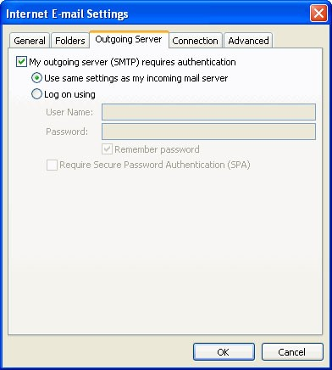

Then select the Advanced tab. You will need to ensure the Incoming server port is set to 110 and the Outgoing Server port is set to 587. Then click OK.
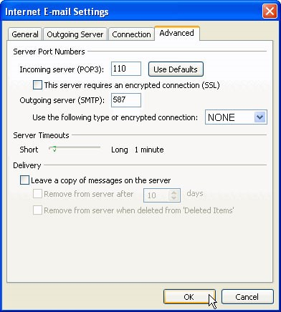
This will take you back to the original email settings screen. Click Next. Click Finish
A confirmation screen will then be display confirming that your account has successfully been setup.

- Setting Up email in Outlook 2010
Once in Outlook 2010, click File from the menu bar. Select the Info option on the left hand menu and select Add Account.
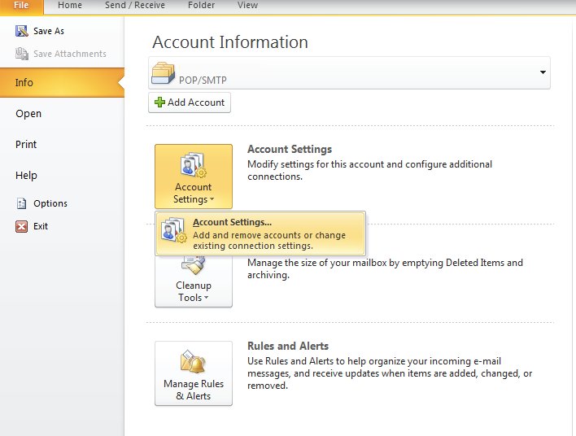

You will be presented with the screen below, click the option for New under the Email Tab.
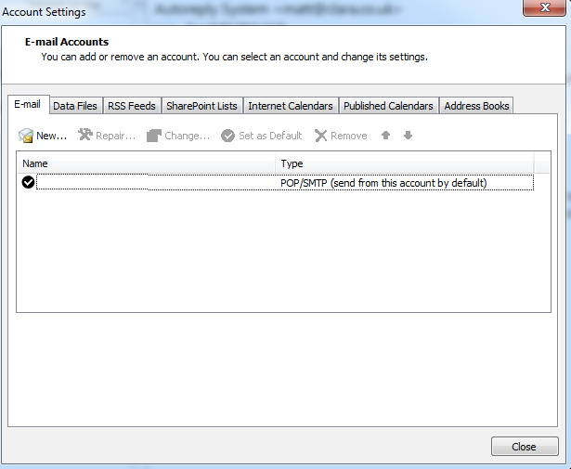

On the next screen you will need to select the option Manually configure the server settings and click Next.
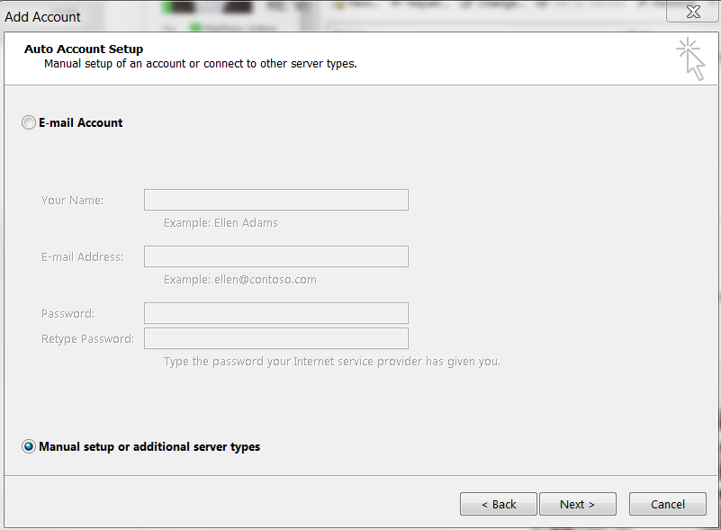

Select Email Account and click Next.
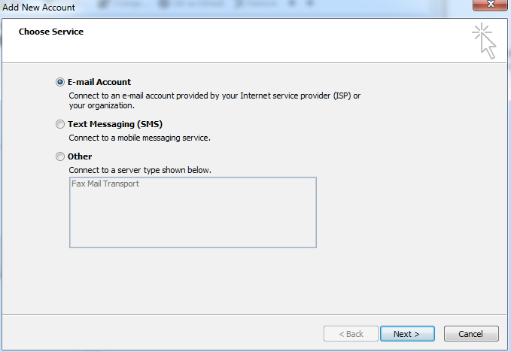
Enter your server settings, pop.clara.net for incoming and relay.clara.net for outgoing, depending on how the account is to be setup, your Username and Password. Then click More Settings.
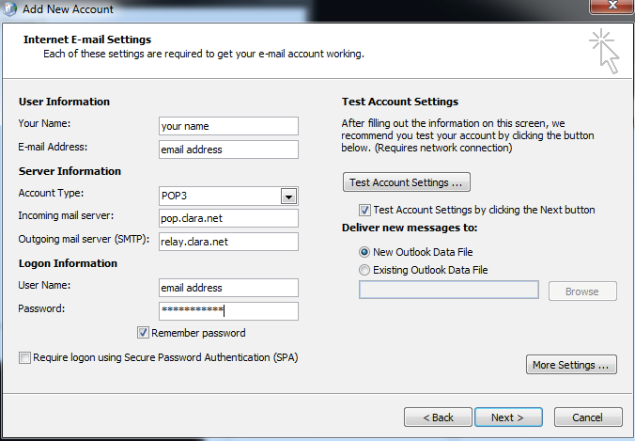

On the following screen select Outgoing Server tab and ensure there is a tick in the My outgoing server (SMTP) server requires authentication box. Then you will need to select the Advanced tab.

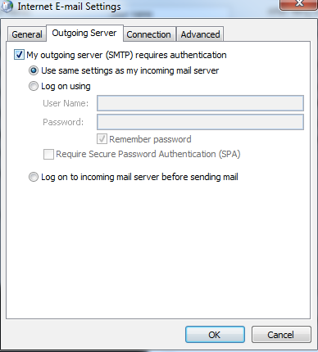
You will need to ensure the Incoming server port is set to 110 and the Outgoing server port is set to 587 and click OK.
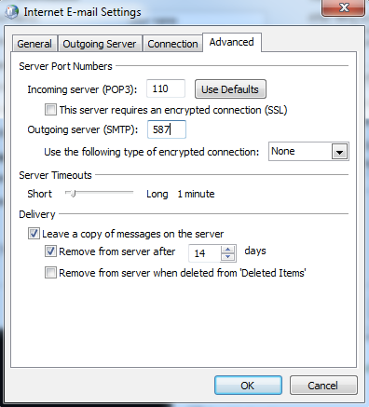
This will take you back to the original email settings screen, click Next.

This confirms that the account has been successfully setup.
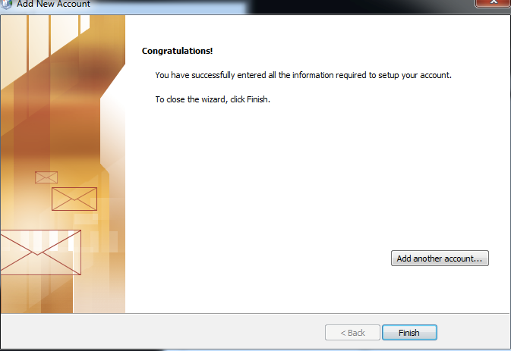

- Setting up email in Outlook 2016/2019/365

Go to File and select Account Settings twice
Select New
Enter email address and select Advanced Options and tick Let me set up my account manually, select Connect
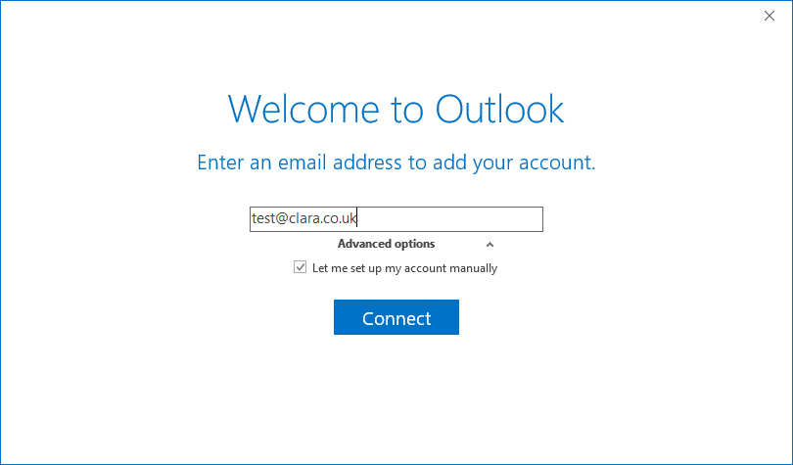

Choose account type (POP)

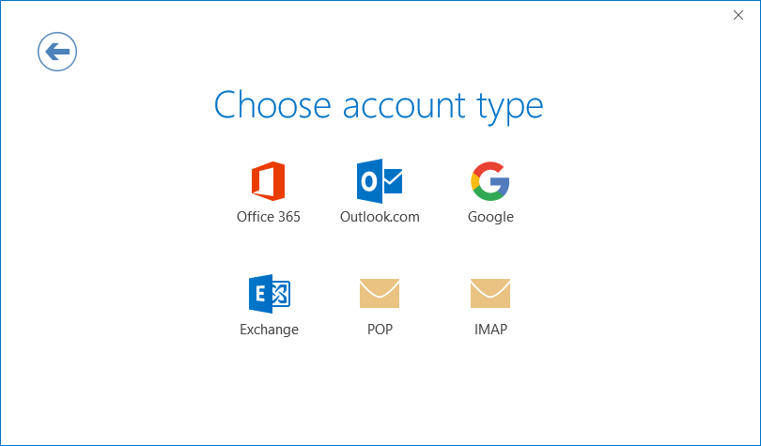
Enter the mail server details as below and click Next

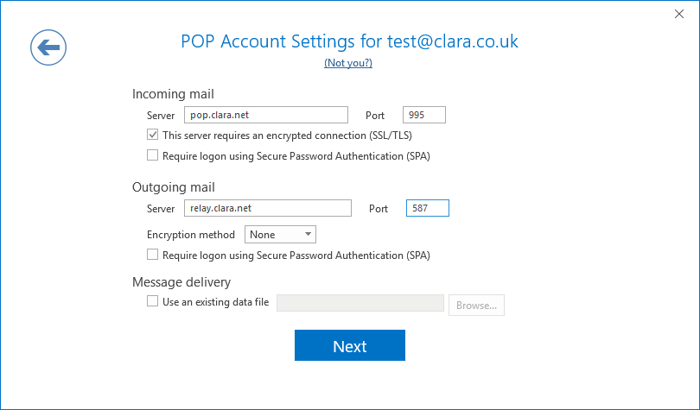

Enter your email address password and click Connect

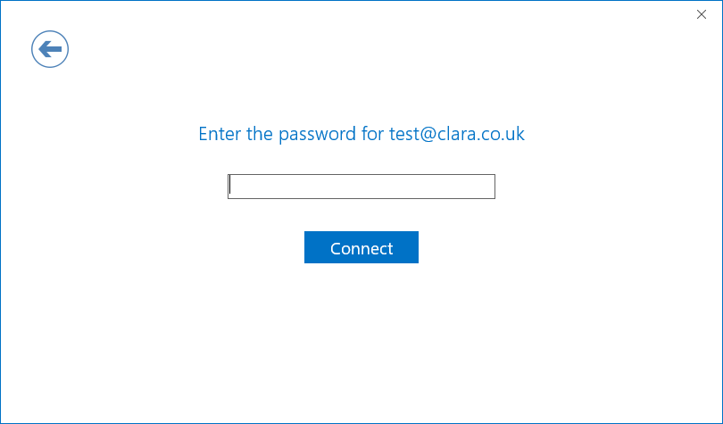

Your account should then be setup and ready to go, click OK

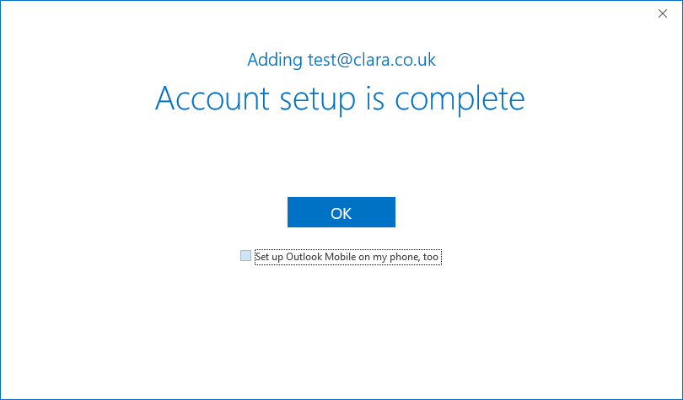

- Setting up email in Outlook 2011 for Mac
When you are in Outlook 2011 for Mac select Tools from the menu bar at the top of the screen and then select Accounts.
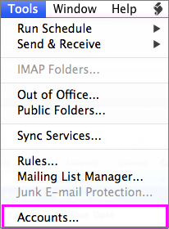
On the following screen it will ask you to choose which type of account you wish to setup, select Add an account image.
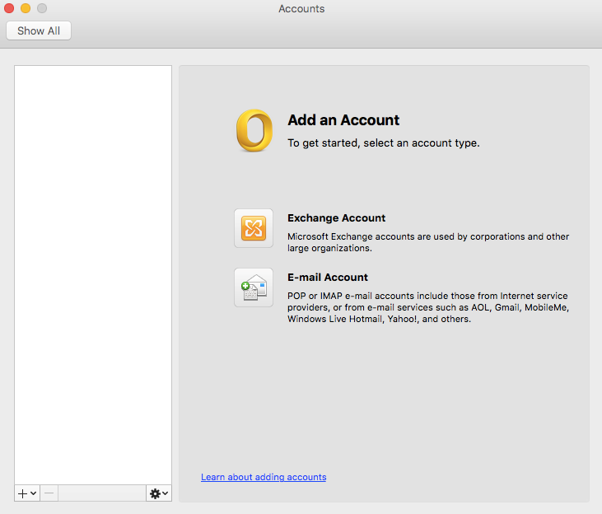

On the following screen you will need to enter all of your account information including your Email Address and Password. The User name will be the full email address and account type set to POP.
You will then need to enter the server names. The incoming server is pop.clara.net and the outgoing is relay.clara.net. You will also need to ensure the incoming port is 110 and the outgoing port is 587 and that SSL is not selected. Then click Add Account.
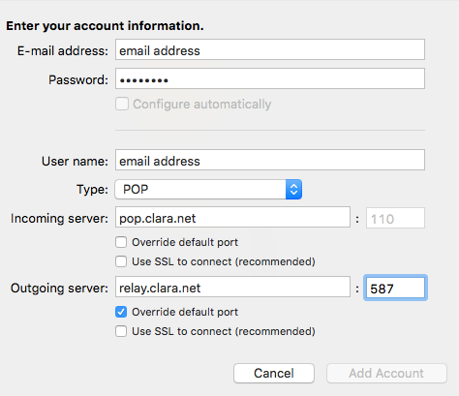
Once added – you will need to click More Settings and ensure Authentication is set to Use Incoming Server Info
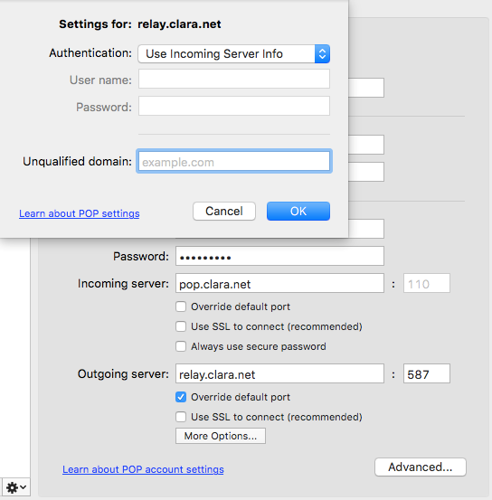

- Setting up email in Outlook 2016 for Mac
First select Tools from the top, then on the drop down, select Accounts.
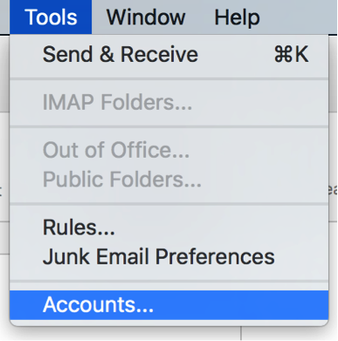
Next, you will need to click the + in the bottom left, then from the drop down, select Other Email.
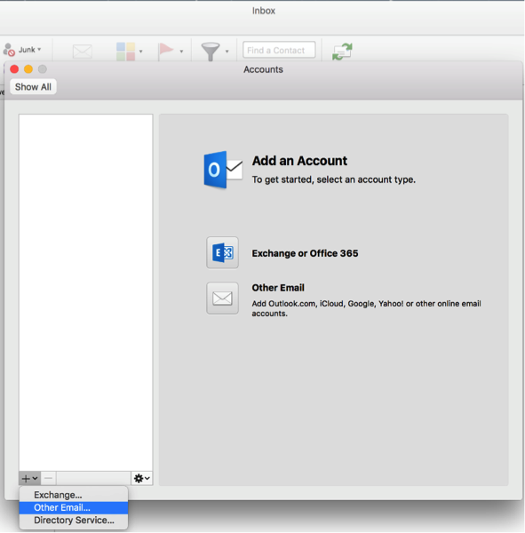

Enter your Email Address and Password. Once you have typed these details in, uncheck Configure automatically. The next part will specify type, this needs to be POP.
It will then request your Server Information. The Incoming Server is pop.clara.net and the Outgoing Server is relay.clara.net. You will need to select Override default port under the Outgoing server then replace port number 25 with 587. Where it asks for a Username you will need to enter the full email address.
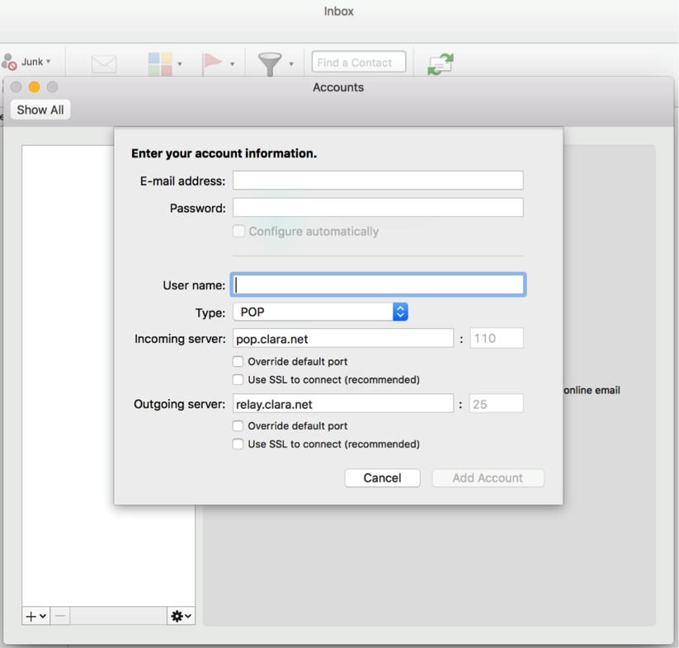
- Setting up email in Windows Live Mail
Select the Accounts tab from the menu bar, and then click the New Email option in the Account tab.
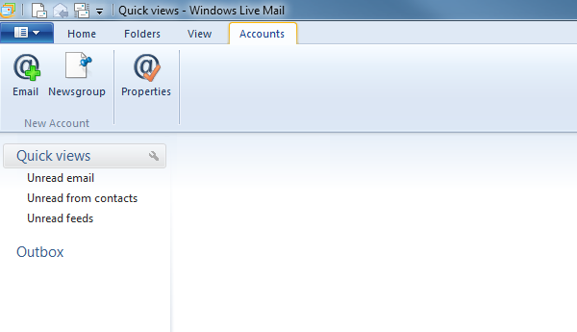
On the following screen you will need to enter your Email Address, Password, and Display Name. Select Manually configure the server settings and click Next.
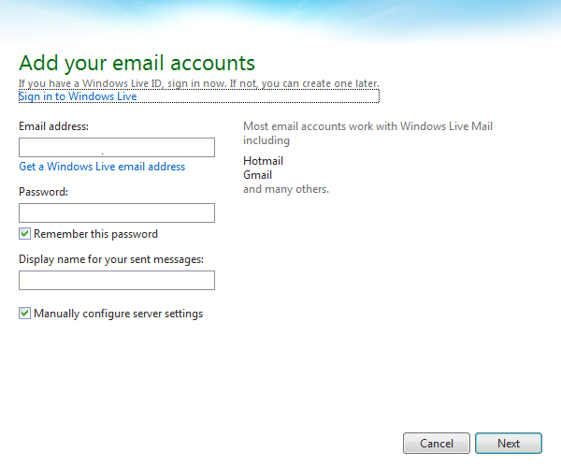
On the following page you will need to enter the server settings. The incoming server is pop.clara.net and the outgoing is relay.clara.net. You will also need to ensure that the incoming port is 110 and the outgoing port is 587, SSL should not be checked.
The authentication type is set to Clear text. Tick the box for Requires authentication and click Next.
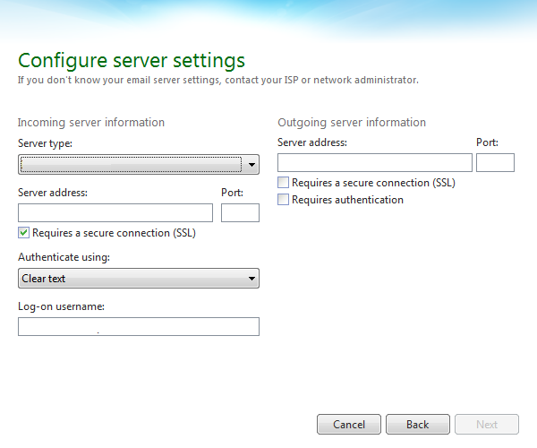

You will then see the following confirmation screen.
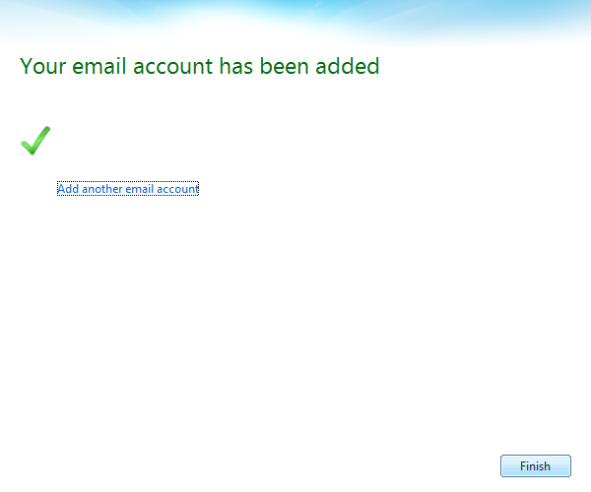

- How to setup email in Windows 10 Mail
First click the settings Icon in the bottom left hand corner of the mail client.

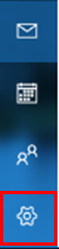

Next click Manage accounts.
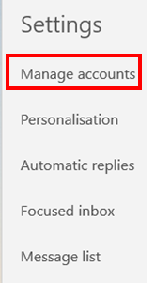
Then Click “Add Account”
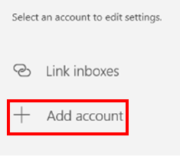
Next click “Advanced setup”
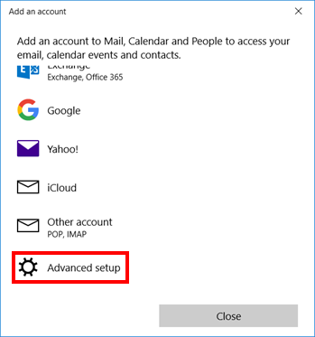

Then Click “Internet email”
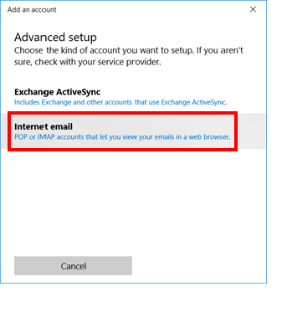
Next fill out the following information with the appropriate information.
In “Email Address” Enter your full email address.
In “Username” enter your full email address a second time.
In “Password” enter your accounts password.
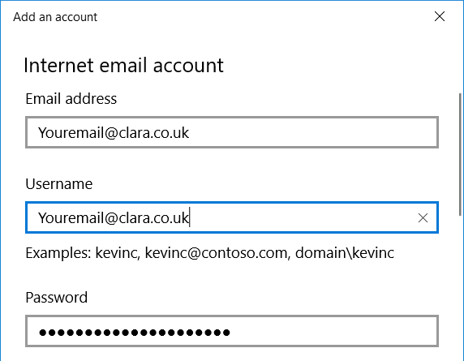

In “Account name” put the first part of your email address (Everything before the @ Symbol)
In “Send messages using your name” enter whatever you would like your name to appear as on emails.
For the “incoming server settings” put pop.clara.net
For the “Account type” ensure that it is displayed as a POP3.
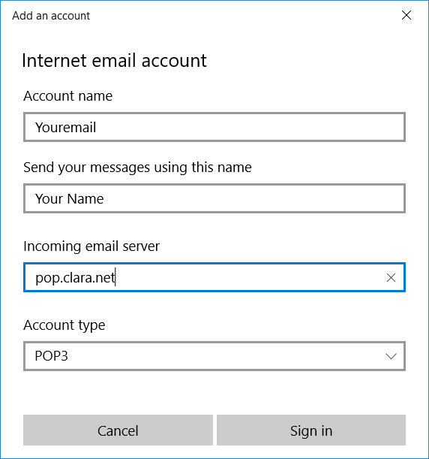

Ensure the “outgoing server (SMTP)” is set to relay.clara.net
Make sure that outgoing server requires authentication is ticked.
Ensure that “use the same username and password for sending emails” is ticked.
Ensure that “Require SLL” is disabled for both incoming and outgoing emails.
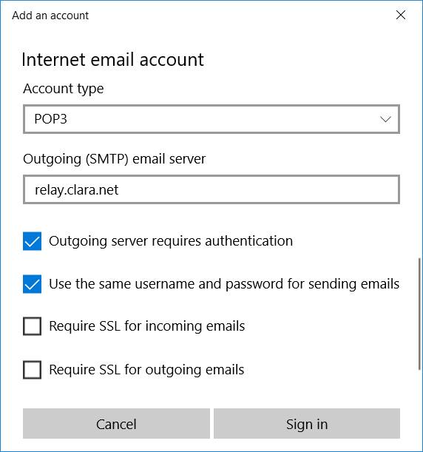

Finally click “Sign in”
Now your account should be completely set up. If your emails aren’t showing up straight away click the “sync” button at the top of your inbox to resync your mailbox to our server.

- How do I set up filters in Webmail
Firstly, you will need sign in to webmail on the following link: https://webmail.clara.net/src/login.php
You will need to sign in with your full email address as the Username and the Password is your email password. Once typed in the information press Login.
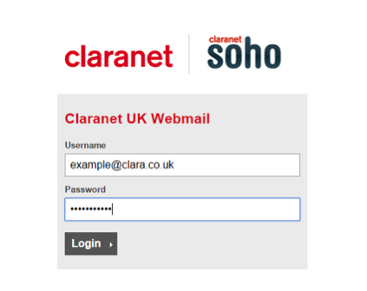

Once you have logged in select Settings in the top right

Select Filters on the left then the + symbol at the bottom

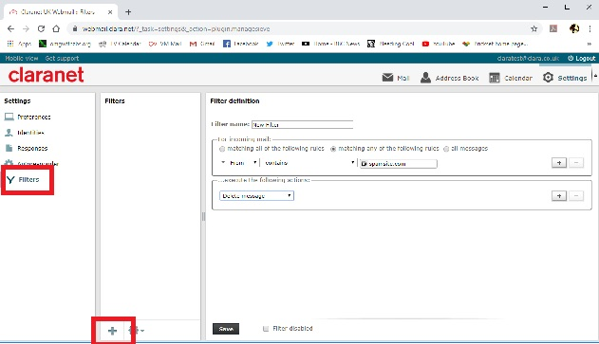

Give the filter a name and select the options you wish the filter to follow, click Save

- Setting up your email account on Apple Mail
To add you email account to Apple Mail, you will firstly need to open Apple Mail by selecting the Mail Stamp logo on the dock station of the screen. Once open, you will need Choose a Mail account provider. You will need to select Other Mail Account on the bottom of the list and press Continue.
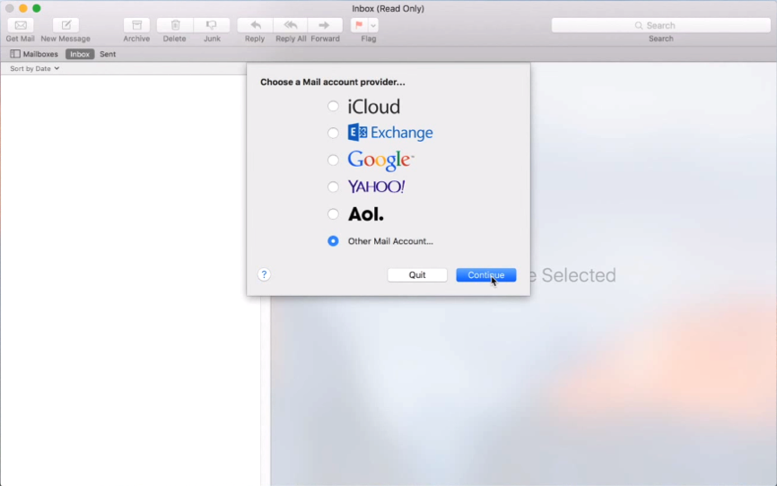

You will then be taken to a page where it will ask for your Name, Email Address and Password. Fill this information in then press Sign In.
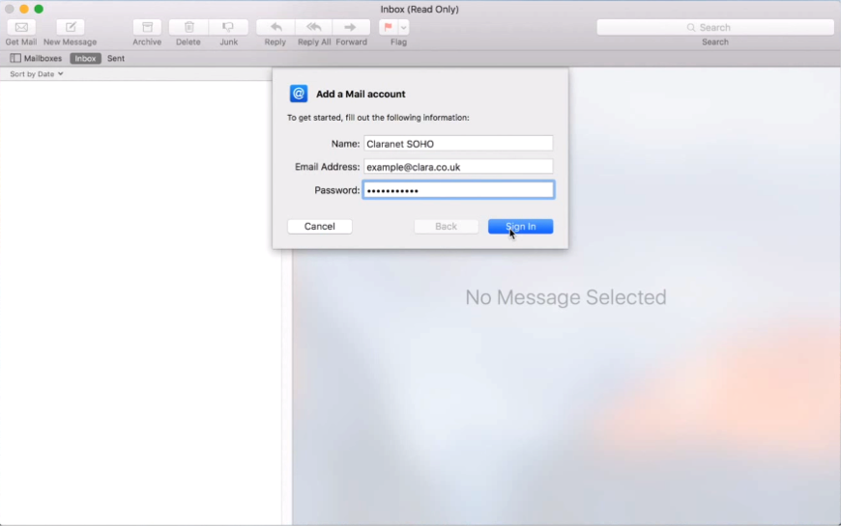

Once you press Sign In, it will display a message saying Unable to verify account name or password. It will also ask for your Username, Account Type, Incoming Mail Server and Outgoing Mail Server. The Username will need to be the Full Email Address. The Account Type needs to be POP. The Incoming Mail Server is pop.clara.net and the Outgoing Mail Server is relay.clara.net. Once you have filled in this information, select Sign In.
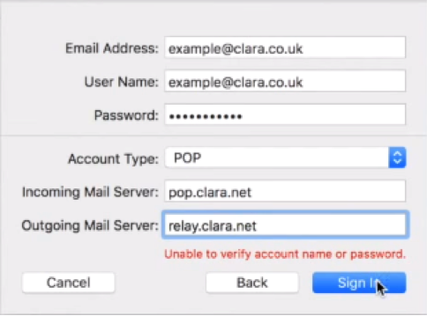
Pressing Sign In will then complete the setup of your emails in Apple Mail.

Email Trouble Shooting
- I received a notification that my mailbox is nearly full?
As the Claranet email platform is a shared platform for all of our customers, all mailboxes on our email servers have limits to the amount of emails/storage they can hold. If your email client is set to leave a copy of messages on the server once the emails have been downloaded then this could result in the mailbox reaching its limit.
To delete emails from the server you will need to login to Webmail and then delete some emails from the Inbox via the webmail. Once you have emptied the emails from the folders you will then need to empty the Trash folder which will clear space within your mailbox, to do this, you will need to select the Purge button. To prevent the mailbox from reaching its limit in the future, you can change your settings within your email client to leave the emails on the server for a shorter period of time, for help with this, contact our Support Team.
- How to access emails whilst abroad
If you need to access your emails whilst you are abroad, then you will need to log in to Webmail from any internet web browser.
You will need to sign in with your full email address as the Username and the Password is your email password. Once typed in the information press Login.

Logging in to webmail will give you the ability to send, receive and view emails within a web browser.
Please Note: Emails that have already been retrieved by your Mail Client will only remain in the webmail site if you have configured your Client to 'Leave a copy of messages on the server'. Otherwise, the mail will be removed from our servers as soon as it is retrieved by your mail client (E.g Outlook)
- How to increase your mailbox size
If you are using one of our hosting packages below:
- Basic
- Enhanced
- Business
- E-Tailer
- Bronze
- Silver
- Gold
You are able to modify the mailbox sizes accordingly to your personal preference. You can increase/decrease the size of the mailbox as required up to a maximum size of 2000MB per mailbox from the allocated size limit you have for your package.
Please note: If you have a @clara.co.uk or @clara.net email address, then unfortunately the mailbox size cannot be changed.
To increase the size of one of the mailboxes you will need to firstly login to your hosting Control Panel by visiting https://admin.clarahost.co.uk. Once logged into the control panel you will need to click on the specific domain on the left hand side of the screen.
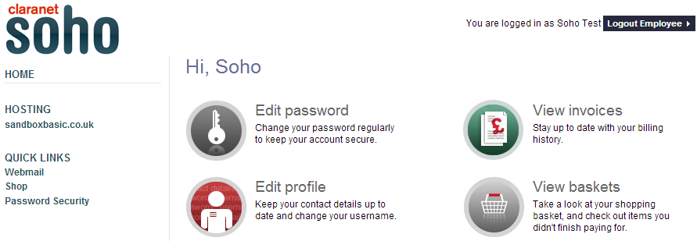
On the next screen firstly click the Email tab and then Email Usage sub option.
On the following screen you will see a list of the current mailboxes and their associated size to the right hand side. You will be able to increase the size of any particular mailbox up to 2000MB dependant on the total Available mail space. To submit the changes made select the Update button.
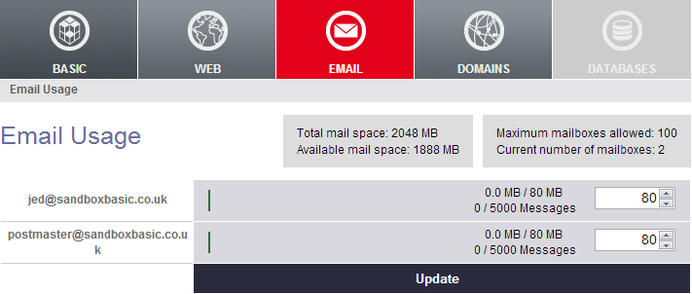

At the top of the screen it will display how much mail space your package contains and also how much un-allocated mail space is available for you to allocate to mailboxes, if you need more Total mail space contact our Support Team for a quote.
- I can receive emails but can’t send emails?
If you are having issues sending emails you will need to ensure you are using relay.clara.net as the outgoing mail server. Often Internet Service Providers can restrict emails being sent from certain port numbers for security reasons. If you have issues sending emails, try using any of the following port numbers:
25, SSL Off.
2525, SSL Off.
587, SSL Off.
465, SSL On.
If you are still having an issue with sending emails after trying any of the above port numbers, it may be that your mail client is not sending out the correct authentication. Make sure you have the correct username and password in your mail client settings and try again. If you still have issues after this, contact our Support Team.
- Why have I suddenly started to receive lots of "message delivery failed" messages?
These types of messages are called bounce backs, and they occur when an email is sent to an address that either does not exist, or is unreachable. If you are receiving a flood of these messages when you have not sent any emails yourself, then there are two possibilities. The first is that your email address is being spoofed by a spammer, in the manner mentioned above. If this is the case, sadly there is little you can do to stop this, though you may be able to find the source of the email from the full headers of the message - this should be quoted in the body of the bounce back message.
Secondly, you could have malware on your machine that is using your computer to send out multiple unsolicited emails. Please be sure that you are running a high-quality, up-to-date firewall program, and a modern up-to-date anti-virus package. Once a full malware scan has been completed on the machine you use for emails we also recommend that you change your email password this can be done by contact our Support Team.

- How can I reduce the amount of spam emails I receive?
If you receive a large number of spam emails to your account, you can add some filters which can send a large amount of these emails to the trash folder within Webmail by blocking particular email subjects or recipients. This can be done by accessing the Filters section in webmail as shown below.

Once you have logged in select Settings in the top right

Select Filters on the left then the + symbol at the bottom

The 3 filters you need to add are as follows

Filter 1
For incoming email

Filter Name: RBL Warning
Subject: ---
Next box: X-RBL-Warning
Leave contains box
Next Box: *

Click the + on the right

Filter 2
For incoming email

Filter Name: Spam Level
Subject: ---
Next box: X-Spam-Level
Leave contains box
Next Box: +++*

Click the + on the right

Filter 3
For incoming email

Filter Name: X Sender
Subject: ---
Next box: X-Sender-Verification-Failed
Leave contains box
Next Box: fail

Execute the following actions

Click drop down and select Move message to
In the next drop down select Junk or Deleted Items
Click Save

